Documentation of Fraud analytics on Bank transactional data

Created a git repo
git remote add origin https://github.com/yourusername/Bank_Transactional_data.git
git branch -M main
git push -u origin main
Connect Local Folder to GitHub Repository
git remote add origin https://github.com/yourusername/Bank_Transactional_data.git
git branch -M main
Add and Commit Your Files
git add .
git commit -m "Initial commit: Added transactional dataset and base scripts"
git push -u origin main

A .gitignore file is created in Git repositories to specify intentionally untracked files and directories that Git should ignore. This prevents these files from being accidentally committed to the repository.

1.2 Configure Git with your name and email
git config --global user.name "Dipanshu Parashar"
git config --global user.email dipanshuparashar902@gmail.com

Initialize a Local Git Repository
cd Bank_Transactional_data
git init
Initialized empty Git repository in /Users/Dipanshu/Bank_Transactional_data/.git/

Data Cleaning Steps
First we check the data for null – if there is any we can replace it median and mode depending on the data for integer value but for non-integer value we can replace it with checking other parameter – tom research this on chat gpt

Then Check the data type and fix the data type
Then check for the unique value for replacing null or duplicate check
Understand the Data Landscape
Step 2: Handle Duplicates
Exact duplicates (every column same):-- df = df.drop_duplicates()
Subset duplicates (e.g., same customer_id + date):-- df = df.drop_duplicates(subset=['customer_id', 'date'], keep='last')
Near duplicates (similar names or categories):
Use fuzzy matching or string normalization before deduplication:
df['customer_name'] = df['customer_name'].str.lower().str.strip()
df['customer_name'] = df['customer_name'].str.replace(r'[^a-z\s]', '', regex=True)

Step 3: Handle Missing Values (Nulls)
Options: for Numerical column
- Imputation with mean/median (for symmetric or skewed data) if we don’t have extreme data then mean but data agar extreme h to median better h
Model-based imputation (if variable is important)
- Use KNN imputation Or regression-based if dependent relationships exist.
Indicator variable approach
Keep missing info by adding a binary flag:
B. Categorical Columns
Replace with mode:
Replace with ‘Unknown’ / ‘Missing’ category:
Predictive filling:
Use frequency encoding + model-based approach for important business variables (e.g., customer_segment).
Step 4: Normalize and Encode
After missing/duplicates handled:
- Numerical scaling (StandardScaler or MinMaxScaler)
Categorical encoding:
- One-hot encoding for low-cardinality: 0 or 1 for 2 categories or less categories but label encoding is for many categories like 5-6 types of values
Step 5: Outlier Handling (Often Overlooked)
Outliers distort imputation and models:
Step 6: Verify Data Integrity Post-Cleaning

The True Flow of a Real Data Science Project
Stage | Phase | Purpose
1️⃣ | Data Collection & Understanding | Gather the raw dataset and metadata (what columns mean, how they’re generated).
2️⃣ | Initial Data Inspection | Quick profiling: check data types, nulls, and duplicates.
3️⃣ | Data Cleaning | Fix or remove incorrect, inconsistent, or missing data.
4️⃣ | EDA (Exploratory Data Analysis) | Explore relationships, distributions, patterns, trends, and hypotheses.
5️⃣ | Feature Engineering | Derive new columns (ratios, flags, etc.) based on insights from EDA.
6️⃣ | Modeling / Dashboarding | Build predictive models or analytical dashboards.
7️⃣ | Validation & Reporting | Confirm results, document, visualize, and communicate findings.

Basic summaries (no heavy plotting yet)
You check:
- Shape of the dataset (rows, columns)
- Data types (numeric vs categorical)

Numeric Columns: Quick stats only
- Mean, median, min, max, standard deviation
- Look for extreme values or impossible numbers.

Categorical Columns: Frequency check
Check for:
- Most common categories (using value_counts)
- Typo or inconsistent entries (e.g., “male”, “Male”, “MALE”)
- Rare categories (<1% of total)

What to do in Deep EDA (after cleaning)
That’s when you go visual and analytical:
Goal | Tool/Plot | Example
Distribution | Histogram / Boxplot | Age distribution of churned vs non-churned
Relationship | Scatterplot / Heatmap | Age vs Balance correlation
Categorical impact | Bar plot / Pie chart | Churn rate by City
Missingness pattern | Heatmap | Visualize missing value patterns
Outlier check | Boxplot | Salary distribution by department
Group stats | Mean/median comparison | Average spend by gender

- Missing values count/
- Duplicates
- Unique value counts
Then convert the time stamp

Simple Explanation of Each Plot
Histogram of TransactionAmount
sns.histplot(df['TransactionAmount'], bins=50, kde=True)
transaction amount ka histogram and bins is kind of interval and KDE is Kernal Density Event draws a smooth curves for probability distribution

• What it does: Draws a histogram — how many transactions fall into different amount ranges
• Why it's useful: You can see if there are:
- Many small transactions (normal)
- A few huge spikes (possible fraud)

Countplot of TransactionHour
sns.countplot(x='TransactionHour', data=df)
- What it does: Counts how many transactions happened during each hour (0–23)
- Why it's useful: Fraud may happen during late-night hours
- You might find that:
  - Normal users transact between 8 AM–9 PM
  - Suspicious activity spikes at 2–4 AM
Example: If you’re a bank, and most activity happens at night for a few customers — it’s a red flag.

Transactions by Channel
sns.countplot(x='Channel', data=df, order=df['Channel'].value_counts().index)
counterplot on channel from data df with the order of each value count in the decending format
- What it does: Shows which channel (ATM, Online, Branch) is used most
- Why it's useful:
  - Online channels may have more risk
  - ATM usage could follow city trends
🧠 Example: If 90% of fraud happens through Online, we can prioritize online transaction checks.

Boxplot of TransactionAmount by TransactionType
- What it does: Compares Debit vs Credit transaction amounts
- Why it's useful:
  - Maybe Credit transactions are larger
  - Or Debit transactions have more outliers (refund fraud)
🧠 Example: You may see credit refunds spiking abnormally in a few accounts — fraud pattern.
Correlation Heatmap
sns.heatmap(df.select_dtypes(include='number').corr(), annot=True)
correlation between two columns
- What it does: Shows which numeric columns are related to each other
- Why it's useful:
  - Helps you avoid duplicate features
  - Shows which features may influence others
Example: If TransactionDuration is strongly correlated with LoginAttempts, maybe the user struggles to complete the transaction → possible user experience issue or bot detection.

Basic plots and observation
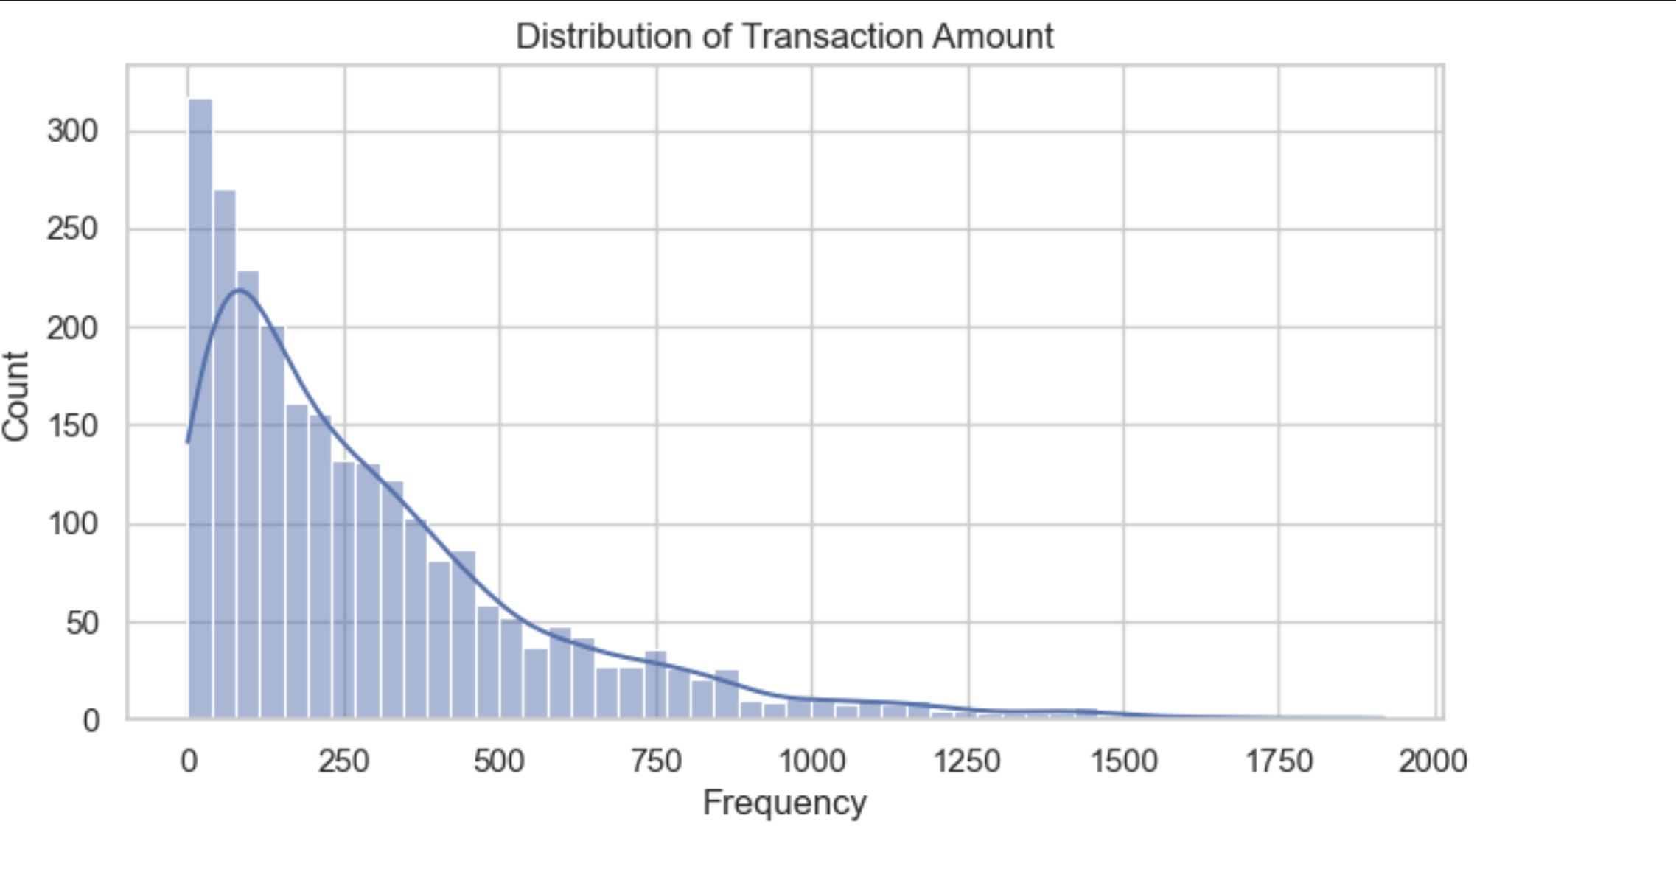

Observation:
- The distribution is right-skewed (positively skewed), meaning most transactions are small, but a few high-value transactions occur.
- The peak is below ₹100–₹150 (mode).
- There are outliers beyond ₹1000, indicating a long tail (possibly suspicious or premium transactions).
- The smooth KDE (blue line) helps highlight this skewness.
Insight:
- You may want to log-transform this feature to normalize it before modeling.
- Use binning or outlier thresholds to flag large transactions as potential fraud risk or VIP behavior.
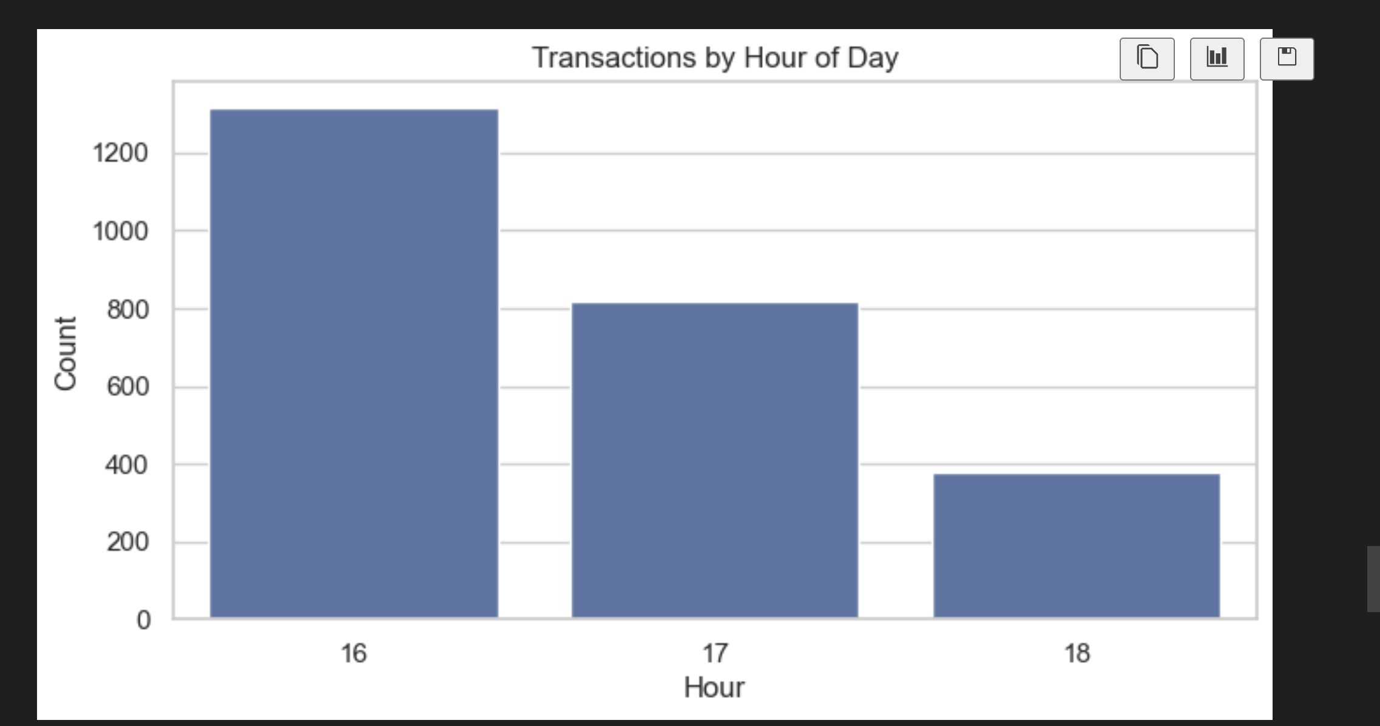

Observation:
- A large number of transactions are clustered around 4 PM (16:00).
- The count drops progressively in the next hours — 5 PM and 6 PM.
- The dataset might be sampled or filtered for afternoon/evening hours only.
Insight:
- Important to validate whether this timing pattern is due to actual business logic (bank hours, business operations).
- Could be used to create features like:
  - IsPeakHour = True if 16:00
  - OffPeak = True for low-activity periods
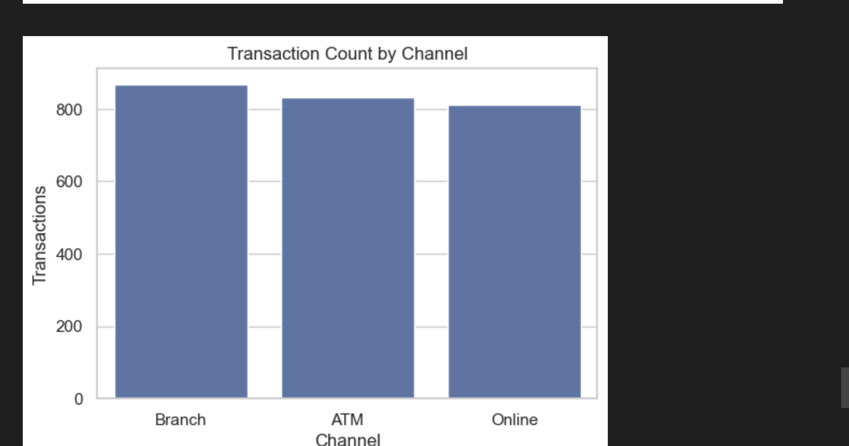
Observation:
- Branch, ATM, and Online channels have almost equal distribution, with Branch slightly leading.
- No single channel dominates significantly.
Insight:
- All channels should be considered equally important in modeling — no need to exclude any.
- You may want to one-hot encode this variable during modeling.
- Investigate channel-specific fraud patterns later.
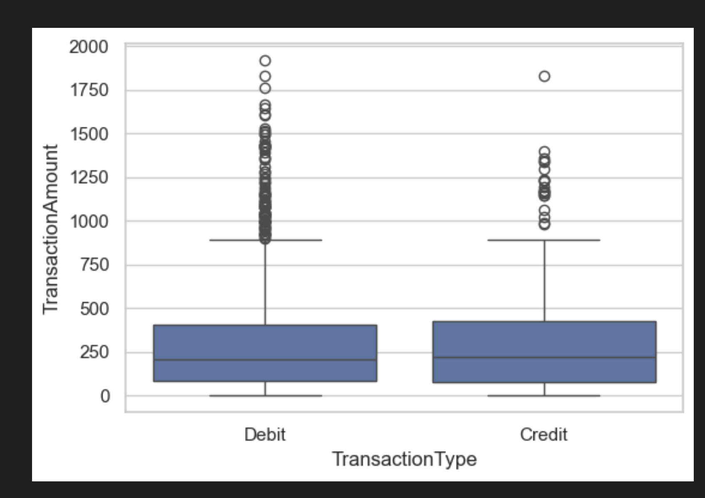

Observation:
- Both Debit and Credit types show similar distributions in terms of median and IQR.
- However, Debit has slightly more outliers — indicating more high-value debit transactions.
- The median transaction value is around ₹250–₹300.
Insight:
- No drastic difference between Debit and Credit, but outlier behavior can be used in fraud detection.
- Could create derived features like:
  - IsHighValueDebit = TransactionAmount > 1000 and TransactionType == 'Debit'

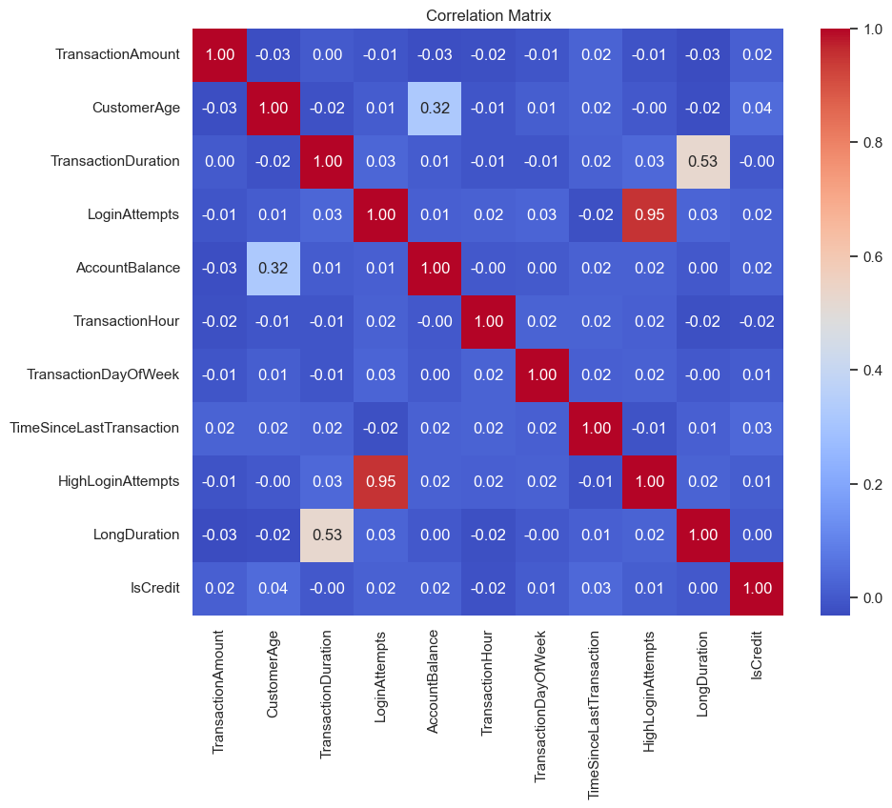
Observation:
- Most features have very low correlation with TransactionAmount (absolute values < 0.1).
- Strongest correlations are:
  - HighLoginAttempts ↔ LoginAttempts (0.95): Redundant
  - LongDuration ↔ TransactionDuration (0.53): Expected
  - CustomerAge ↔ AccountBalance (0.32): Older customers tend to have slightly higher balances.
Insight:
- You may want to drop one of the highly correlated pairs (HighLoginAttempts or LoginAttempts).
- Not much linear predictive power of other features for TransactionAmount, so consider using non-linear models (e.g., Random Forest).
- Features like TransactionHour and IsCredit show no strong correlation, but could still be categorical indicators in modeling.

Note
You can recalculate recency per account like this (we’ll do it in a later feature engineering step). For now, we won’t drop this — just note that these are simulated dates, and the field needs adjustment before modeling.

Updated Project Path: Unsupervised Fraud Detection

🔶 STEP 11A: Preprocessing for Clustering
- Encode categorical columns (Channel, TransactionType, etc.)
- Scale numerical features (StandardScaler or RobustScaler)

🔶 STEP 11B: Apply Clustering (e.g., KMeans)
- Run KMeans with 2–5 clusters
- Use silhouette score to validate fit
- Visualize clusters using PCA or t-SNE (2D plot)

🔶 STEP 11C: Analyze Clusters
- Describe each cluster
- Identify which cluster(s) may contain fraudulent behavior based on:
  - High login attempts
  - Long duration
  - High amount
  - Odd hours

🔶 STEP 11D: Rule-Based Clustering
- Create binary features based on fraud indicators (as in your rules)
- Run KMeans or DBSCAN using only these rules
- Label cluster(s) as fraud-prone based on composition

🔶 STEP 11E: Combine Clustering + Rule Signals
- Combine cluster assignment + rule score
- Create is_fraud_simulated = 1 if:
  - Cluster is risky AND rule score ≥ 2

from sklearn.preprocessing import StandardScaler
from sklearn.preprocessing import LabelEncoder

# Create a copy to cluster
df_cluster = df.copy()

# Encode categorical features
le_channel = LabelEncoder()
le_txn_type = LabelEncoder()
df_cluster['ChannelEncoded'] = le_channel.fit_transform(df_cluster['Channel'])
df_cluster['TxnTypeEncoded'] = le_txn_type.fit_transform(df_cluster['TransactionType'])

# Select only numeric and encoded columns
features_to_cluster = [
'TransactionAmount', 'TransactionHour', 'TransactionDuration',
'LoginAttempts', 'AccountBalance', 'CustomerAge',
'TimeSinceLastTransaction', 'ChannelEncoded', 'TxnTypeEncoded'
]

# Fill any potential missing values in clustering features
df_cluster[features_to_cluster] = df_cluster[features_to_cluster].fillna(0)

# Scale features
scaler = StandardScaler()
X_scaled = scaler.fit_transform(df_cluster[features_to_cluster])

LabelEncoder()
- Creates an instance of the encoder — it doesn’t encode yet, just prepares the tool.
- You’re creating one encoder per categorical column (good practice).

🔹 .fit_transform()
- .fit() → learns which unique categories exist.
- .transform() → replaces each category with a number.
- .fit_transform() → does both at once.
- Suppose df['Channel'] looks like:
['Online', 'Branch', 'ATM', 'Online', 'ATM']
ChannelEncoded = [2, 1, 0, 2, 0]

.fit_transform()
- .fit() → calculates the mean and standard deviation of each feature.
- .transform() → scales the data using this formula:
$$z=\frac{(x-\text{mean})}{\text{std deviation}}$$
So each column gets transformed so that:
- Mean = 0
- Standard deviation = 1
Example:
Original | After Scaling
100 | 1.2
200 | 0.3
800 | -1.1
from sklearn.cluster import KMeans
from sklearn.metrics import silhouette_score
from sklearn.decomposition import PCA
import matplotlib.pyplot as plt
import seaborn as sns

# STEP 1 — Try different cluster counts (2–6) to find the best K
scores = {}
for k in range(2, 7):
km = KMeans(n_clusters=k, random_state=42, n_init=10)
labels = km.fit_predict(X_scaled)
sil = silhouette_score(X_scaled, labels)
scores[k] = sil
print(f"K={k} → Silhouette Score = {sil:.3f}")

# STEP 2 — Pick the best K (highest silhouette score)
best_k = max(scores, key=scores.get)
print(f"\n✅ Best number of clusters: K={best_k} with silhouette score={scores[best_k]:.3f}")

# STEP 3 — Fit final KMeans model
kmeans = KMeans(n_clusters=best_k, random_state=42, n_init=10)
labels = kmeans.fit_predict(X_scaled)

# STEP 4 — Add cluster labels back to the DataFrame
df_cluster['Cluster'] = labels

# STEP 5 — Reduce to 2D for plotting
pca = PCA(n_components=2, random_state=42)
X_pca = pca.fit_transform(X_scaled)
df_plot = pd.DataFrame(X_pca, columns=['PC1', 'PC2'])
df_plot['Cluster'] = labels

# STEP 6 — Plot clusters in 2D PCA space
plt.figure(figsize=(8,6))
sns.scatterplot(data=df_plot, x='PC1', y='PC2', hue='Cluster', palette='Set2', s=60)
plt.title(f"KMeans Clustering (Best K = {best_k})")
plt.xlabel("Principal Component 1")
plt.ylabel("Principal Component 2")
plt.legend(title='Cluster')
plt.grid(True)
plt.tight_layout()

What happens here:

🔹 scores = {}
Creates an empty dictionary to store the silhouette score for each cluster number k.

🔹 for k in range(2, 7):
You’ll test k = 2, 3, 4, 5, 6 clusters — common practice to find the best number of clusters.

🔹 KMeans(n_clusters=k, random_state=42, n_init=10)
- n_clusters=k → how many clusters to form.
- random_state=42 → ensures results are reproducible.
- n_init=10 → K-Means will run 10 times with different initializations and pick the best result (prevents bad random starts).

🔹 labels = km.fit_predict(X_scaled)
- fit_predict() = fits the K-Means model and assigns each record to a cluster.
- labels = array of cluster IDs (e.g., [0, 1, 1, 0, 2, …]).

🔹 silhouette_score(X_scaled, labels)
The silhouette score measures how well each point fits within its cluster compared to others.
- Ranges from -1 to +1
  - +1 = well separated clusters
  - 0 = overlapping clusters
  - -1 = points in the wrong cluster
✅ Higher = better.
K=2 --> Silhouette Score = 0.115
K=3 --> Silhouette Score = 0.132
K=4 --> Silhouette Score = 0.131
K=5 --> Silhouette Score = 0.129
K=6 --> Silhouette Score = 0.131
K=3 and K=6

What PCA does
PCA = Principal Component Analysis, a dimensionality-reduction technique.
🧠 It projects high-dimensional data (your 9 features) onto 2 dimensions (PC1, PC2) that capture most of the data’s variance.
That means:
- You can now plot complex multi-feature data on a simple 2-axis chart.
- You preserve most of the structure of the data, but in 2D space.

Silhouette + PCA + KMeans in summary
Step | Concept | Why It Matters
1 | Try multiple K values | Find optimal cluster count
2 | Evaluate with silhouette score | Quantitatively measure cluster quality
3 | Fit final KMeans | Assign each record to its cluster
4 | Add cluster labels to data | Enable group analysis
5 | Use PCA to reduce to 2D | Allow visualization
6 | Plot results | Visually verify separation

Now that you know the best K, you train your final clustering model on the full dataset.
- labels → again, the cluster assignments for every row in your data.
Each customer or transaction now belongs to a specific cluster (e.g., Cluster 0, Cluster 1, etc.).

Step 1: Understand what increasing K does
When you increase K:
- Clusters become smaller and more specific.
- But also more fragmented — you start splitting natural groups into subgroups.
Imagine 3 big circles (natural groups) in your data.
If you force K=6, each circle may get divided into two smaller pieces, even though those halves are similar.
✅ So fewer clusters (smaller K) means:
- Simpler interpretation
- More general patterns
- Better for storytelling and business decisions
❌ Larger K means:
- Over-segmentation
- Harder to interpret (“too many micro-groups”)
- Risk of capturing noise as a pattern

🧩 Step 2: The rule of thumb — choose the simpler model
When two K values give similar silhouette scores, always prefer the smaller K, unless you have a strong business reason to split further.
This follows Occam’s Razor — prefer the simplest model that explains the data equally well.
✅ In your case:
K=3 and K=6 both perform equally well,
but K=3 is simpler, more stable, and easier to explain.
So you’d pick K = 3.

What You’ve Done So Far:
- Preprocessed numerical and encoded categorical features
- Scaled the data using StandardScaler
- Determined optimal clusters using Silhouette Score
- Visualized clusters using PCA
- Found K=3 as the best value with Silhouette Score = 0.132

What This Means:
You’ve segmented transaction behaviors into 3 groups (clusters), without needing a fraud label, which is ideal when no explicit fraud tag exists. These clusters can help:
- Identify anomalous patterns (e.g., low-frequency behavior)
- Create heuristics or rules per cluster
- Lay the foundation for semi-supervised or label propagation techniques

Step 12 — Cluster Interpretation (Profiling Summary)
Feature | Cluster 0 | Cluster 1 | Cluster 2 | Interpretation
CustomerAge | 55.2 | 27.7 | 46.2 | Cluster 1 = Youngest users
AccountBalance | 7036.1 | 2110.1 | 5249.3 | Cluster 0 = Highest balance
LoginAttempts | ~1.12 all | ~1.12 all | ~1.14 | Similar login behavior
TxnTypeEncoded | 1.0 | 1.0 | 0.0 | Cluster 2 = Credit users
ChannelEncoded | 0.85 | 0.98 | 1.30 | Cluster 2 = Possibly mobile or web heavy
TransactionAmount | 277.7 | 321.1 | 306.5 | Cluster 1 has slightly higher txn volume
TimeSinceLastTransaction | all values ~ -41M to -43M | (Check: maybe these timestamps are not in expected unit, or scaled wrongly)

🧠 Suggested Business Interpretation:
- Cluster 0: Older, high-balance users → 🟢 May be trusted customers
- Cluster 1: Young, low-balance, high debit users → 🔴 Potential fraud-prone
- Cluster 2: Credit-heavy users, average balance → 🟡 Could be intermittent users or under review

Step 13A: Create Rule-Based Fraud Label
df_cluster['RuleBasedFraud'] = 0

# Rule logic (you can tune these thresholds)
df_cluster.loc[
(df_cluster['LoginAttempts'] > 5) |
(df_cluster['AccountBalance'] < 1000) |
(df_cluster['CustomerAge'] < 30) |
(df_cluster['TransactionAmount'] > 1000), # unusually high txn
'RuleBasedFraud'
] = 1
What it does:
- Creates a new column called RuleBasedFraud in your DataFrame df_cluster.
- Sets the default value to 0 for all rows, meaning “not fraudulent”.

df_cluster.loc[condition, 'RuleBasedFraud'] = 1
- .loc[] lets you select rows by condition and update them.
- If the condition inside parentheses is True, then the 'RuleBasedFraud' column will be set to 1 for that row.

🔹 The conditions:
You’ve defined four rule triggers (joined by |, which means “OR”):
Let’s unpack:
- df_cluster.groupby('Cluster') → groups your data by cluster ID from K-Means.
- ['RuleBasedFraud'] → focuses only on that column.
- .agg(['count', 'sum', 'mean']) → applies three aggregation functions:
Function | Meaning | Example
count | Total transactions in each cluster | e.g., 1000 rows
sum | Number of fraud-flagged rows (since 1 = fraud) | e.g., 120 frauds
mean | Proportion of fraud (fraud rate = frauds ÷ total) | e.g., 0.12 = 12% fraud rate
- .reset_index() → turns the grouped output back into a clean DataFrame (so Cluster becomes a normal column again).

What You’ve Done So Far (All Steps Complete Up to Step 14):

✅ Step 11B: Apply KMeans
- You applied KMeans clustering on scaled, encoded features.
- Found K=3 to be optimal based on silhouette score.
- Assigned Cluster labels to the data.

✅ Step 12: Profile the Clusters
- You computed mean feature values per cluster.
- Visualized cluster profiles using a heatmap.

✅ Step 13: Rule-Based Fraud Labeling
- You applied a rule-based fraud heuristic (based on threshold or known fraud markers).
- Calculated fraud rate per cluster:
  - Cluster 1 (High fraud rate = 81%)
  - Cluster 2 (Moderate = 33%)
  - Cluster 0 (Low = 6%)

✅ Step 14: Add Hybrid FraudRiskLevel
- You mapped clusters to FraudRiskLevel (Low/Moderate/High) based on observed fraud rates.
✔️ So, nothing is pending from the planned steps so far — you’re fully done up to Step 14.

📊 Now, Your Key Question:

"Which is better – Rule-Based vs Clustering vs Hybrid?"
Let’s evaluate:

🔹 1. Rule-Based Tagging
Pros:
- Simple and explainable.
- Works well if you have strong domain rules (e.g. “4+ login attempts + high amount = likely fraud”).
Cons:
- Might miss fraud if fraudsters change tactics (rule circumvention).
- Hardcoded rules don’t generalize or adapt.

🔹 2. Clustering Alone
Pros:
- Unsupervised → useful when labels (fraud/not) are unreliable or missing.
- Can find anomalous behavior patterns missed by rules.
- Helps segment users or transactions based on latent patterns.
Cons:
- Doesn’t label anything as fraud directly — it only groups similar behavior.
- Needs interpretation (e.g. high-amount + low-account balance = risky?).

🔹 3. Hybrid: Cluster + Rule-Based
What You Did in Step 14
Pros:
- Best of both worlds.
- Clusters identify behavioral segments, then you overlay rules to label risk based on actual fraud rates in clusters.
- Gives you a data-driven risk stratification:
  - Cluster 1 → high fraud rate → High Risk
  - Cluster 0 → low fraud → Low Risk
Cons:
- Still semi-automated, not predictive unless tied to future fraud outcomes.

clustering
unsupervised learning
use this rule make the cluster by comibination of cluster
baseline Decsion tree se start
random forest
Xg boost
light gpm
ensemble model

